Stop 5G!
Stay Connected but Protected.
Community Event!
Join local community members and safe technology experts to learn how 5G impacts us, our kids, and the environment.
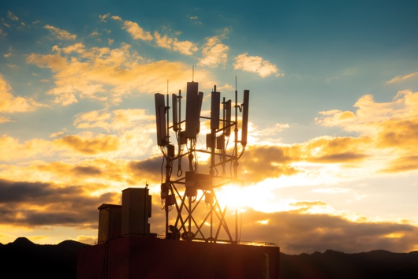
Screening of documentary "Generation Zapped" followed by a Q & A discussion with Cece Doucette, National 5G Expert and Director of MA 4 Safe Technology and Nate Johnson, Electromagnetic Radiation Specialist (EMRS)

When: Thursday September 22, 2022
Time: 12:30-3pm (documentary screening until 1:45; Q&A after)
Where: Washburn Library 5244 Lyndale Ave S Minneapolis
Zoom Option: Can't be there in person? Join us on Zoom!
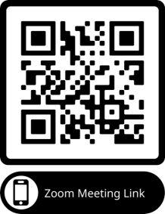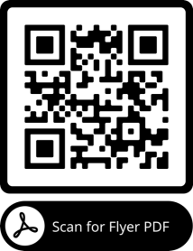
Want more info on 5G issues, Check out above QR Code!

